

**Ethics Pledge**

**Consistent with the above statements, all homework exercises, tests and exams that are designated as individual assignments MUST contain the following signed statement before they can be accepted for grading.**

I pledge on my honor that I have not given or received any unauthorized assistance on this assignment/examination. I further pledge that I have not copied any material from a book, article, the Internet or any other source except where I have expressly cited the source.

Signature: Haodong Zhao Date: Mar 11th 2019

Please note that assignments in this class may be submitted to www.turnitin.com, a web- based anti-plagiarism system, for an evaluation of their originality.

1. The plant manager wants to investigate the productivity of three groups of workers: those with little (A), average (B), and considerable work experience (C). Since the productivity depends to some degree on the day-to-day variability of the available raw materials, which affects all groups in a similar fashion, the manager suspects that the comparison should be blocked with respect to day. The results (productivity, in percent) from five production days are given in the following table:



* + 1. Assuming the underlying assumptions of ANOVA are met, are there differences in the mean productivity among the three groups? (Use α = 0.05.)

Answer:

H0: uA = uB = uC

H1: not H0

α = 0.05

Because the underlying assumptions of ANOVA are met, we can directly use one-way ANOVA test.

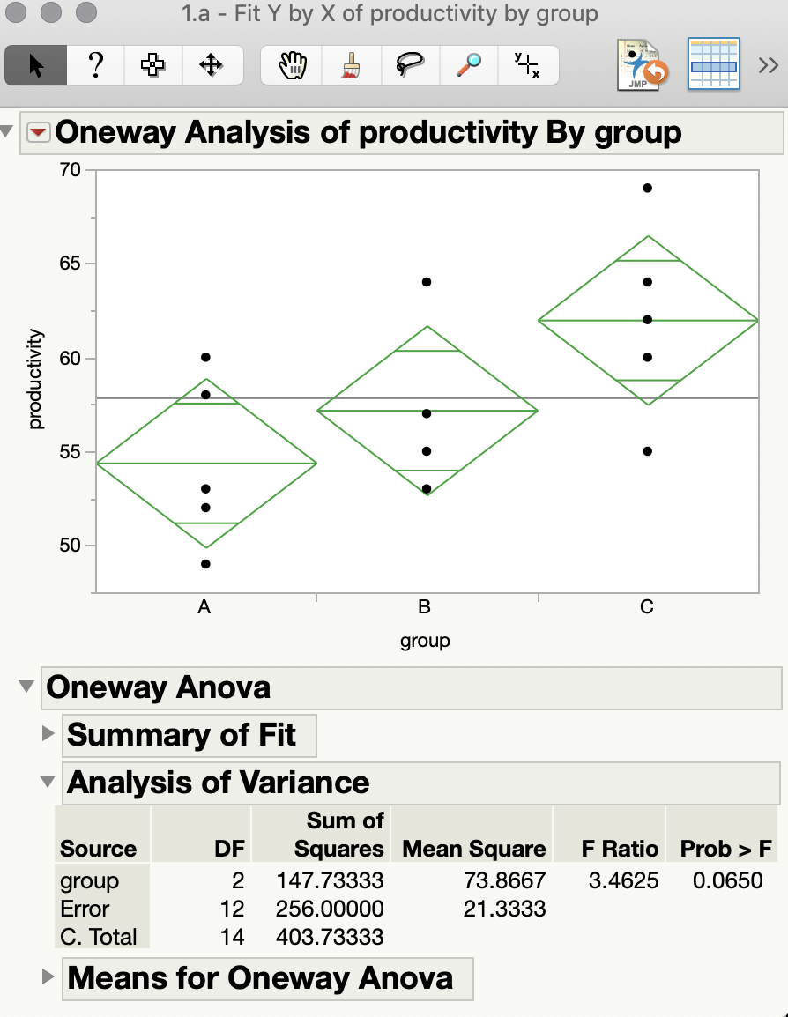

From a one-way ANOVA test, we get the p-value = 0.065, which is greater than α = 0.05, so we cannot reject H0, there are not significant differences in the mean productivity among the three groups at 95% confidence interval.

* + 1. Has the blocking made a difference? That is, is there a difference in results between one-way ANOVA without blocks and one-way ANOVA with blocks?

Answer:

H0: all mean values are same

H1: not H0

α = 0.05

In this problem, blocks are days, so we set day as the block in one-way ANOVA test.

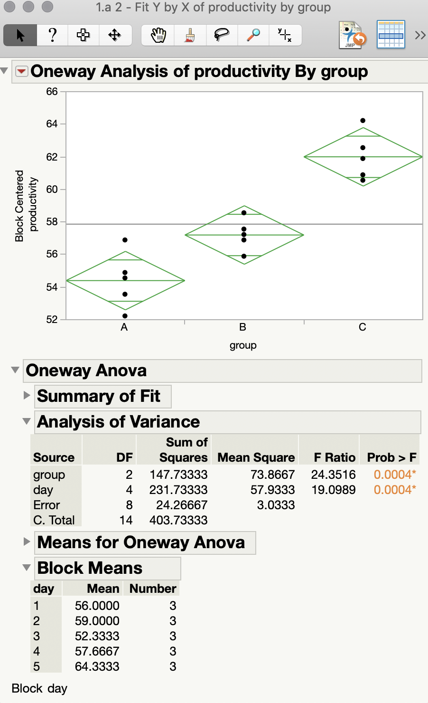

By setting block in one-way ANOVA test, we get 2 p-values which are both 0.0004, which are less than α = 0.05. Therefore, we can reject H0 and say block effect result at 95% confidence interval. There is a significant difference in results between one-way ANOVA without blocks and one-way ANOVA with blocks.

1. Suppose you want to determine whether the brand of laundry detergent used and the temperature affects the amount of dirt removed from your laundry. To this end, you buy two different brand of detergent (“Super” and “Best”) and choose three different temperature levels (“cold”, “warm”, and “hot”). Then you divide your laundry randomly into 6 × r piles of equal size and assign each r piles into the combination of (“Super” and “Best”) and “cold”, “warm”, and “hot”).

We are interested in testing Null Hypotheses

H0D: The amount of dirt removed does not depend on the type of detergent  
H0T: The amount of dirt removed does not depend on the temperature  
H0DT: There is no interaction effect between the type of detergent and the temperature.

This experiment has two factors (Factor Detergent, Factor Temperature) at a = 2 (Super and Best) and b = 3 (cold, warm, and hot) levels. Thus, there are ab = 32 = 6 different combinations of detergent and temperature. With each combination you wash r = 4 loads and r is called the number of replicates. This sums up to n = abr = 24 loads in total. The amounts Xijk of dirt removed when washing sub pile k (k = 1, 2, 3, 4) with detergent i (i = 1, 2) at temperature j (j = 1, 2, 3) are recorded in the following Table. Perform appropriate analysis to test the above three hypotheses with α = 0.05.



Answer:

r = 4, a = 2, b = 3, n = a*b*r = 24, α = 0.05

factor1: Factor Detergent

factor2: Factor Temperature

H0D: The amount of dirt removed does not depend on the type of detergent

u1=u2  
H0T: The amount of dirt removed does not depend on the temperature

u1=u2=u3  
H0DT: There is no interaction effect between the type of detergent and the temperature.

DT=0

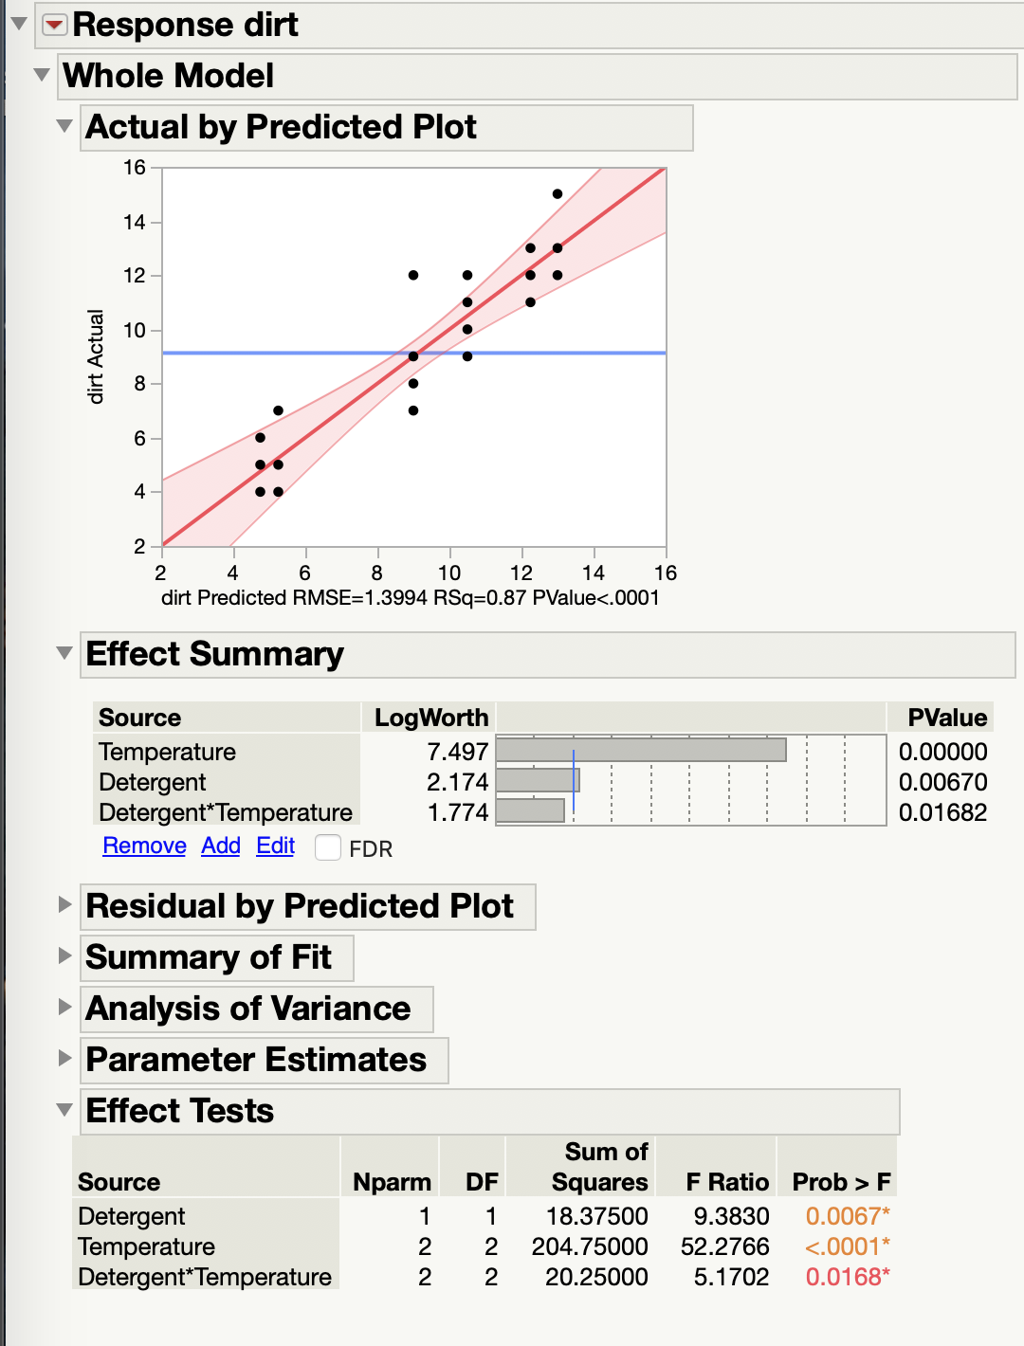

By using two-way ANOVA test, we can get the p-value for Detergent is 0.0067, p-value for Temperature is less than 0.0001 and p-value for Detergent*Temperature is 0.0168. All these three p-values are less than α = 0.05, so we can reject H0D, H0T and H0DT. Therefore, the amount of dirt removed depend on the type of detergent at 95% confidence interval, the amount of dirt removed depend on the temperature at 95% confidence interval. And there is interaction effect between the type of detergent and the temperature at 95% confidence interval.